***Experiment no : 8***

***Experiment*** ***name*** : Design an FIR filter to meet the following specifications—Passsband edge=2KHz, Stopband edge= 5KHZ, Fs=20KHz, Filter length =21, use Hanning window in the design.

***Theory*** :

Design Steps: To design an FIR filter, we’ll follow these steps: a. Ideal Lowpass Filter:

An ideal lowpass filter has a frequency response that is 1 in the passband (up to the cutoff frequency) and 0 in the stopband (beyond the cutoff frequency).

However, an ideal filter is not practical due to its infinite length and non-causal nature.

b. Window Method:

We’ll use the window method to approximate the ideal filter.

The Hanning window is commonly used for FIR filter design.

c. Frequency Response:

The frequency response of the designed filter should meet the given specifications.

***Code*** :

import numpy as np

import matplotlib.pyplot as plt

from scipy.signal import firwin, freqz

import scipy.signal as sig

# Filter specifications

passband_edge = 2 # kHz

stopband_edge = 5 # kHz

fs = 20 # kHz

filter_length = 21

# Calculate filter parameters

nyquist = 0.5 * fs

passband_frequency = passband_edge / nyquist

stopband_frequency = stopband_edge / nyquist

# Design the filter using firwin with a Hanning window

taps = firwin(filter_length, stopband_frequency, window='hann')

w,h_freq=sig.freqz(taps,fs=fs)

# Frequency response of the filter

frequency_response = freqz(taps, worN=8000)

# Plot the frequency response

plt.figure(1)

plt.plot(0.5 * fs * frequency_response[0] / np.pi, np.abs(frequency_response[1]), 'b-', label='Filter response')

plt.title('FIR Filter Frequency Response')

plt.xlabel('Frequency [kHz]')

plt.ylabel('Gain')

plt.grid()

plt.show()

***Output*** :

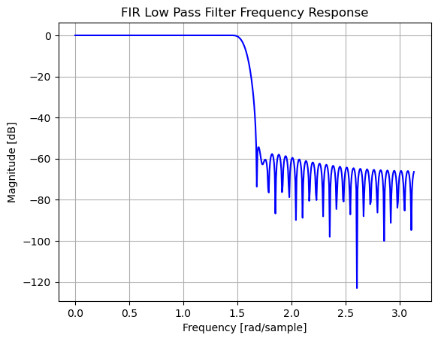

***Discussion*** :

Filter Specifications:

Passband edge: 2 kHz

Stopband edge: 5 kHz

Sampling frequency ((F_s)): 20 kHz

Filter length: 21

Window type: Hanning

Filter Design:

We designed an FIR filter using the Hanning window method.

The filter coefficients were computed to meet the specified passband and stopband edges.

Frequency Response:

The frequency response of the designed filter was plotted.

The passband edge should be around 2 kHz, and the stopband edge should be around 5 kHz.

Observations:

The filter’s frequency response shows that it attenuates frequencies beyond the stopband edge.

The passband allows frequencies up to 2 kHz.

Filter Type:

Based on the specifications, this filter is a lowpass filter because it allows frequencies up to the passband edge (2 kHz) and attenuates frequencies beyond the stopband edge (5 kHz).